Tenant

Subscriptions

Resource Group

Resource groups

Resources

Storage account – datalakeprojectnetflix

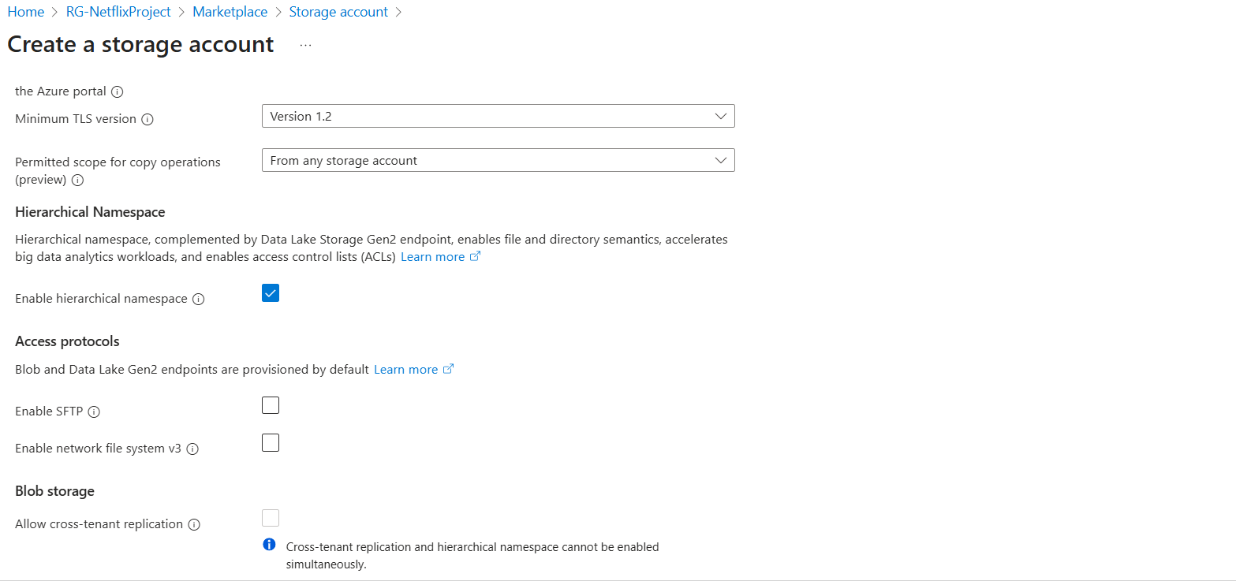

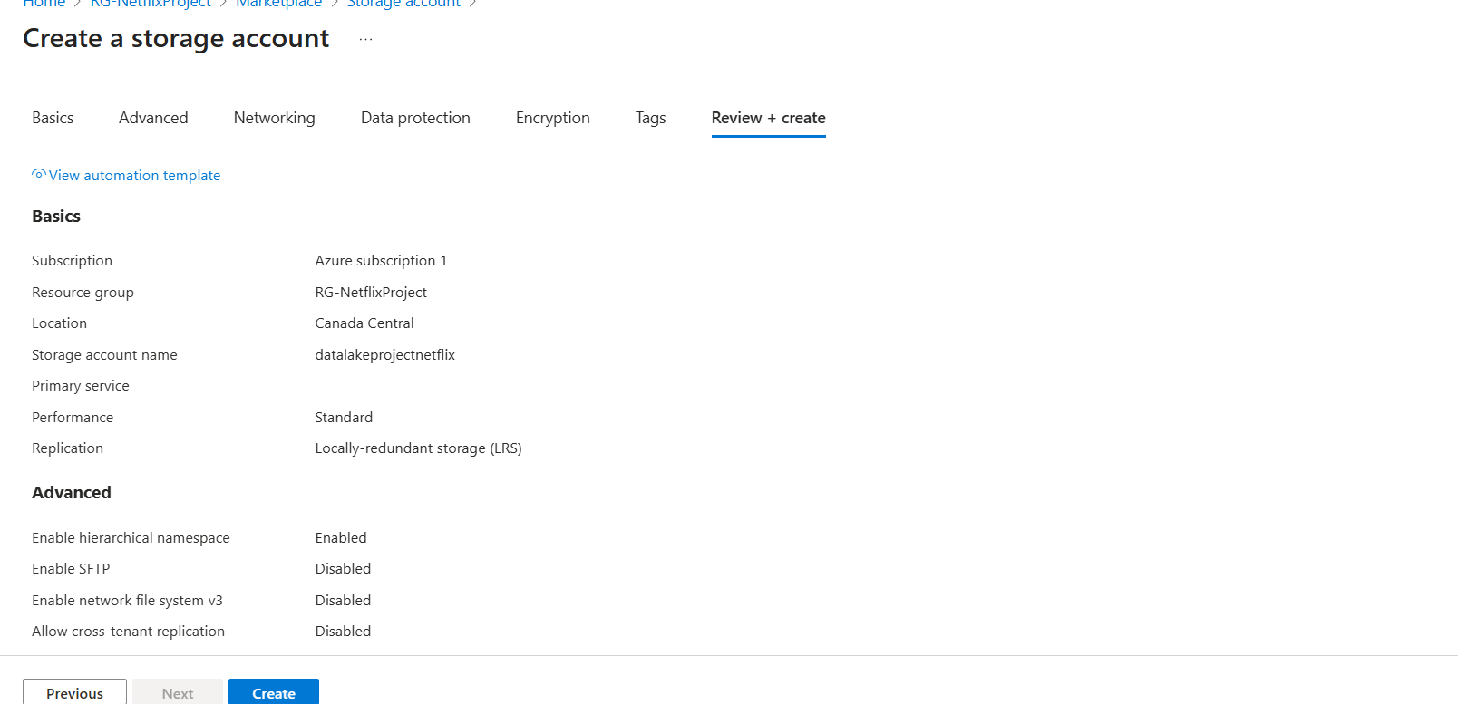

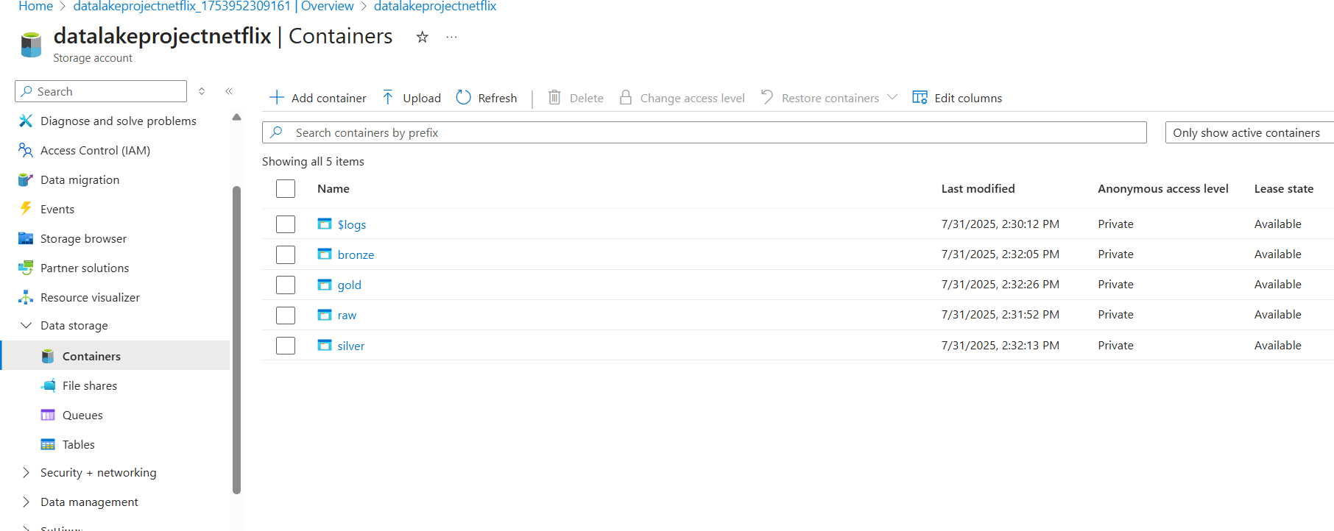

Azure Data Factory

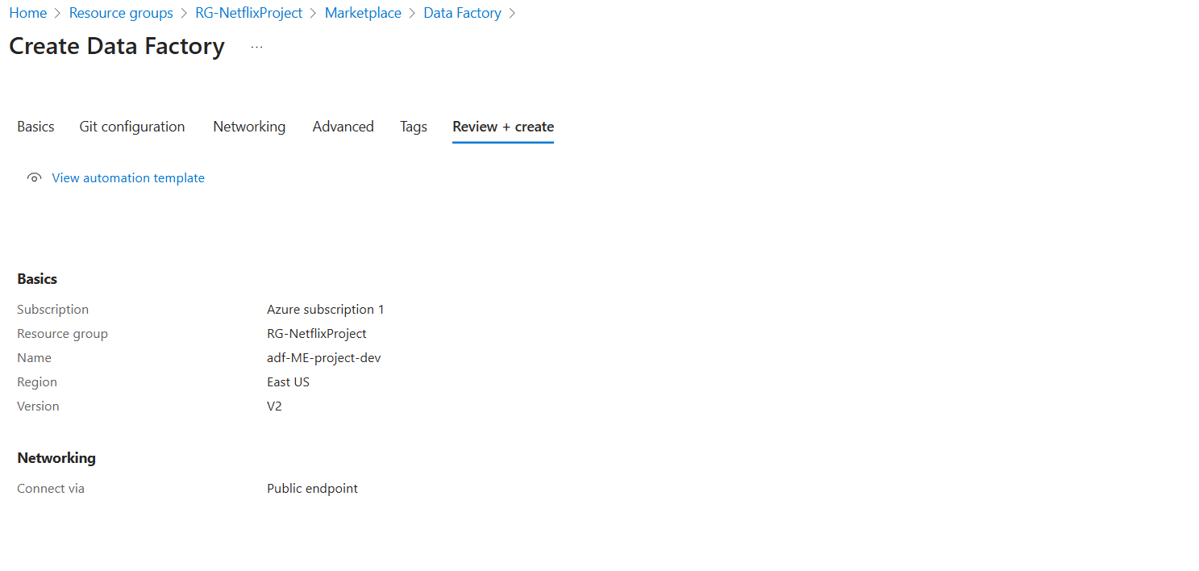

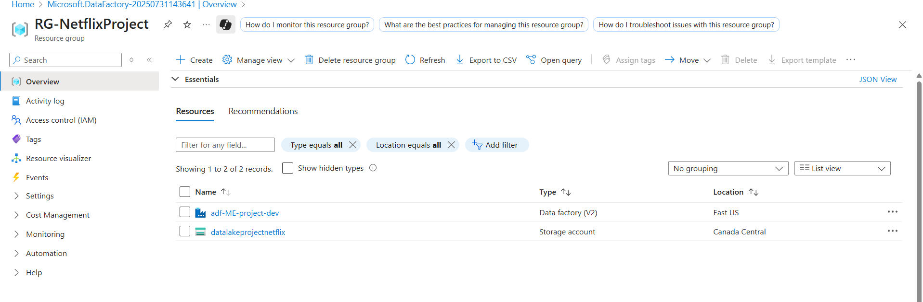

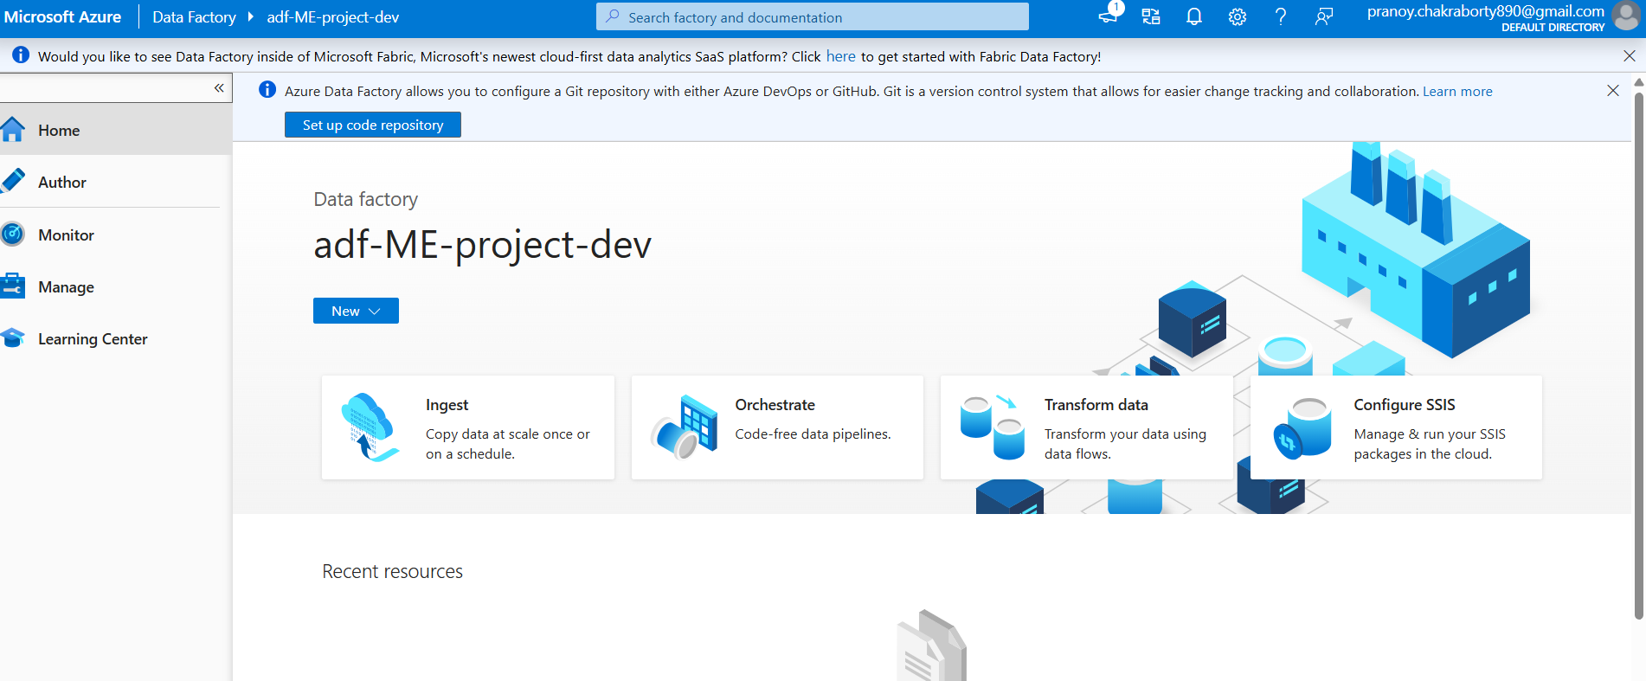

GitHub 🡪 ADF 🡪 Data Lake (storage account)

Create connection

For github use http

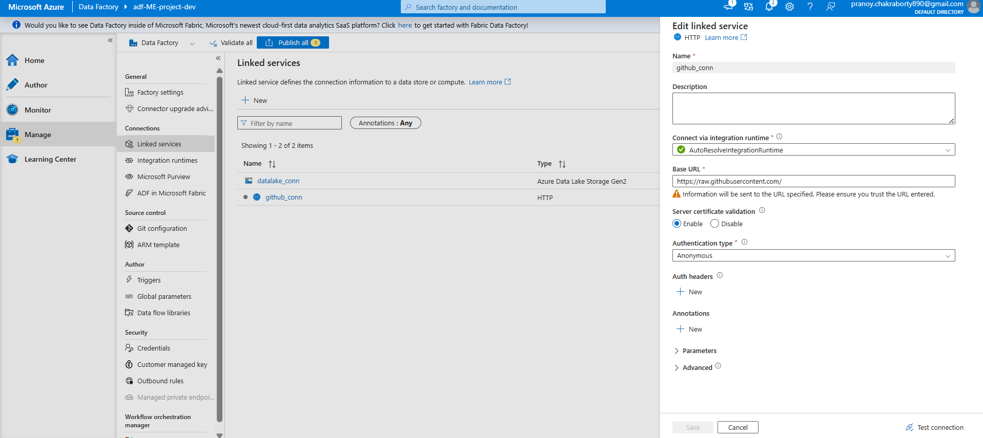

For data lake, use Azure Data Lake Storage Gen 2

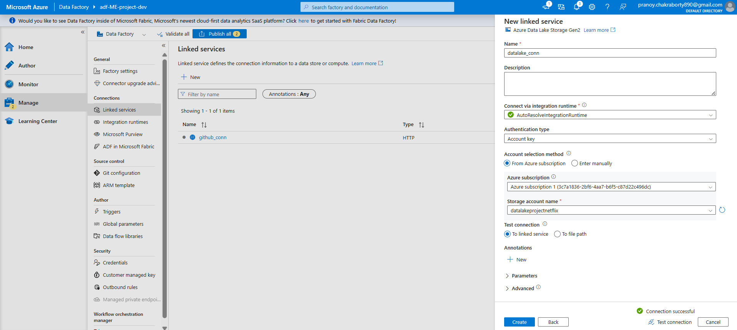

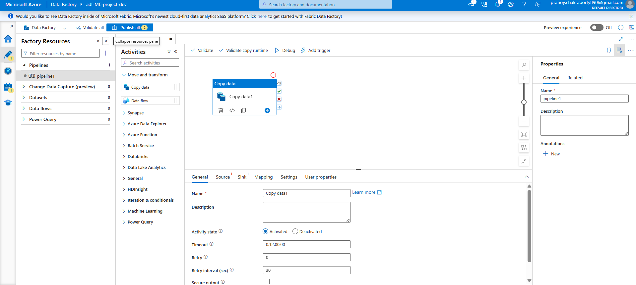

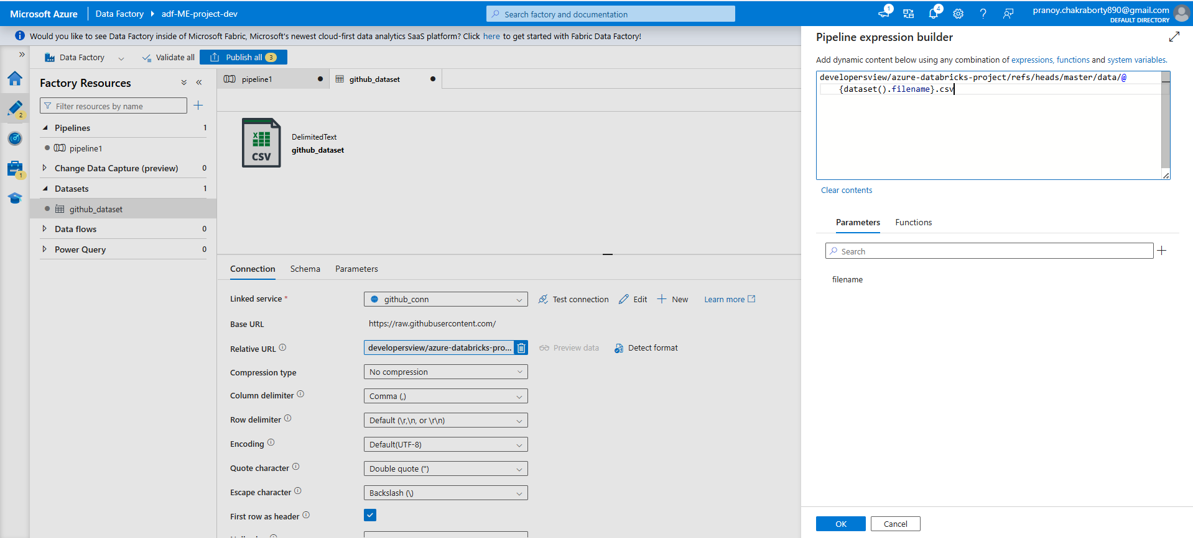

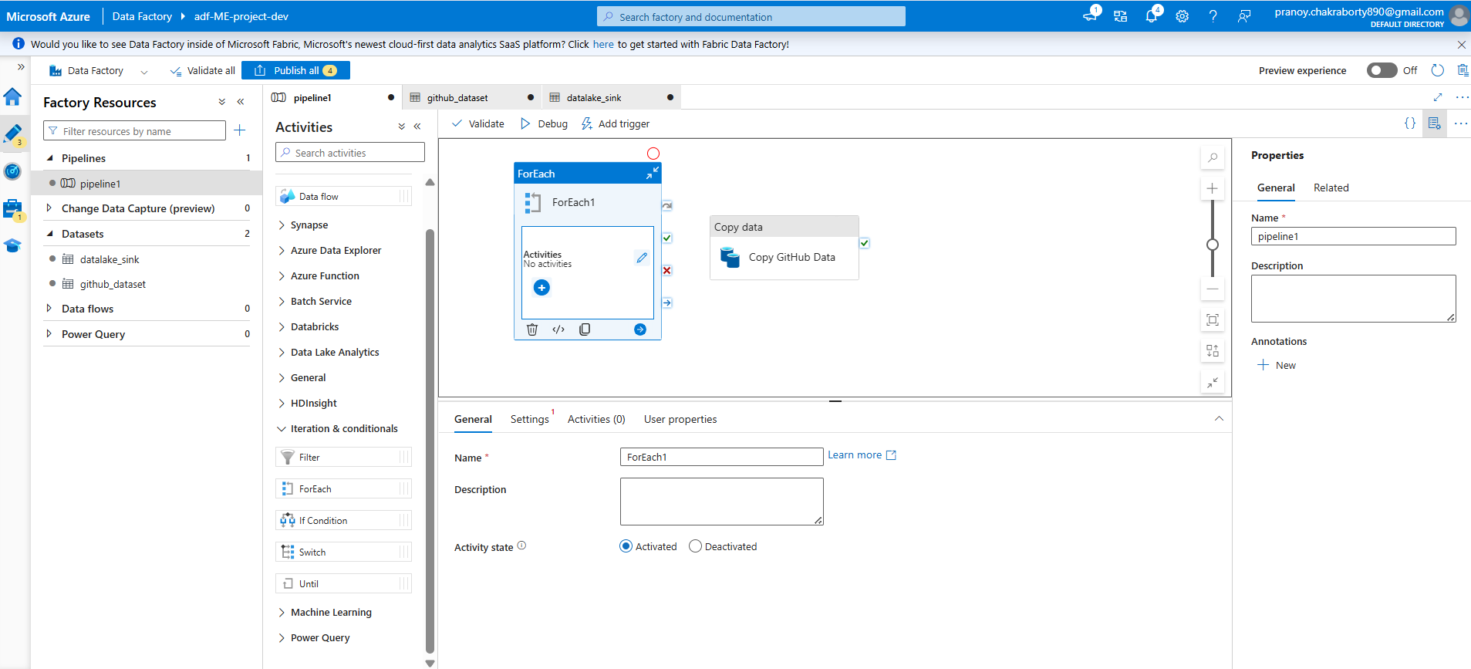

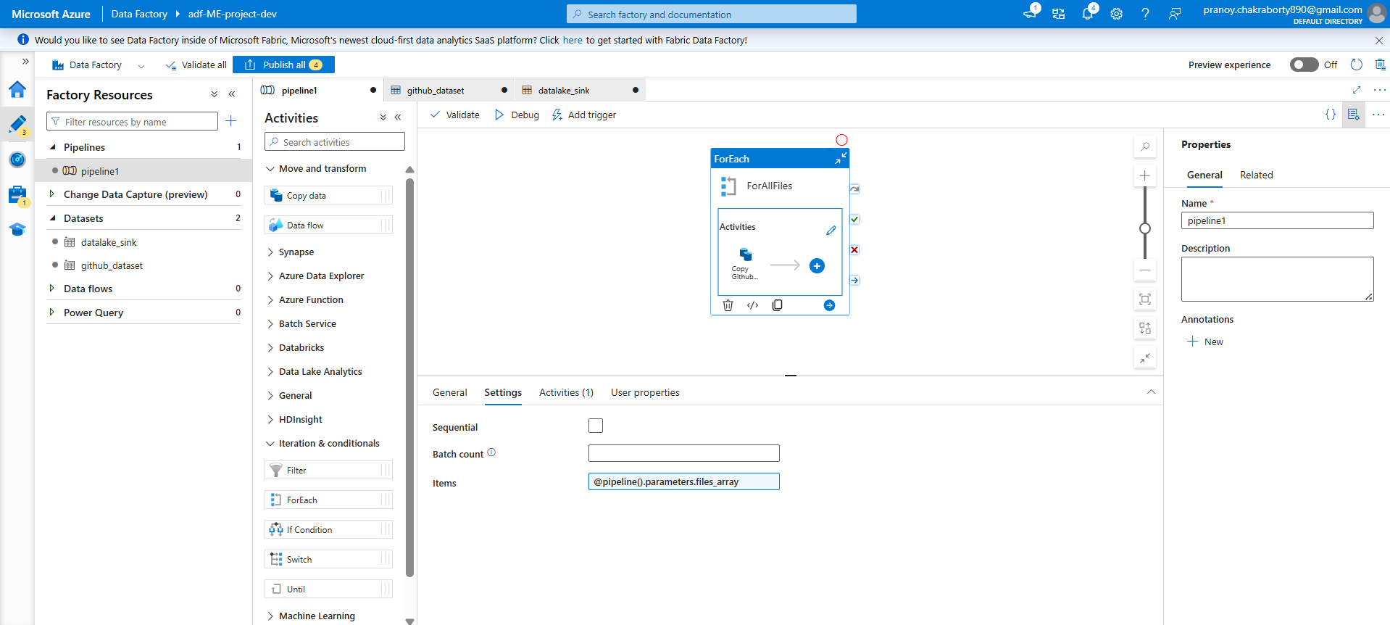

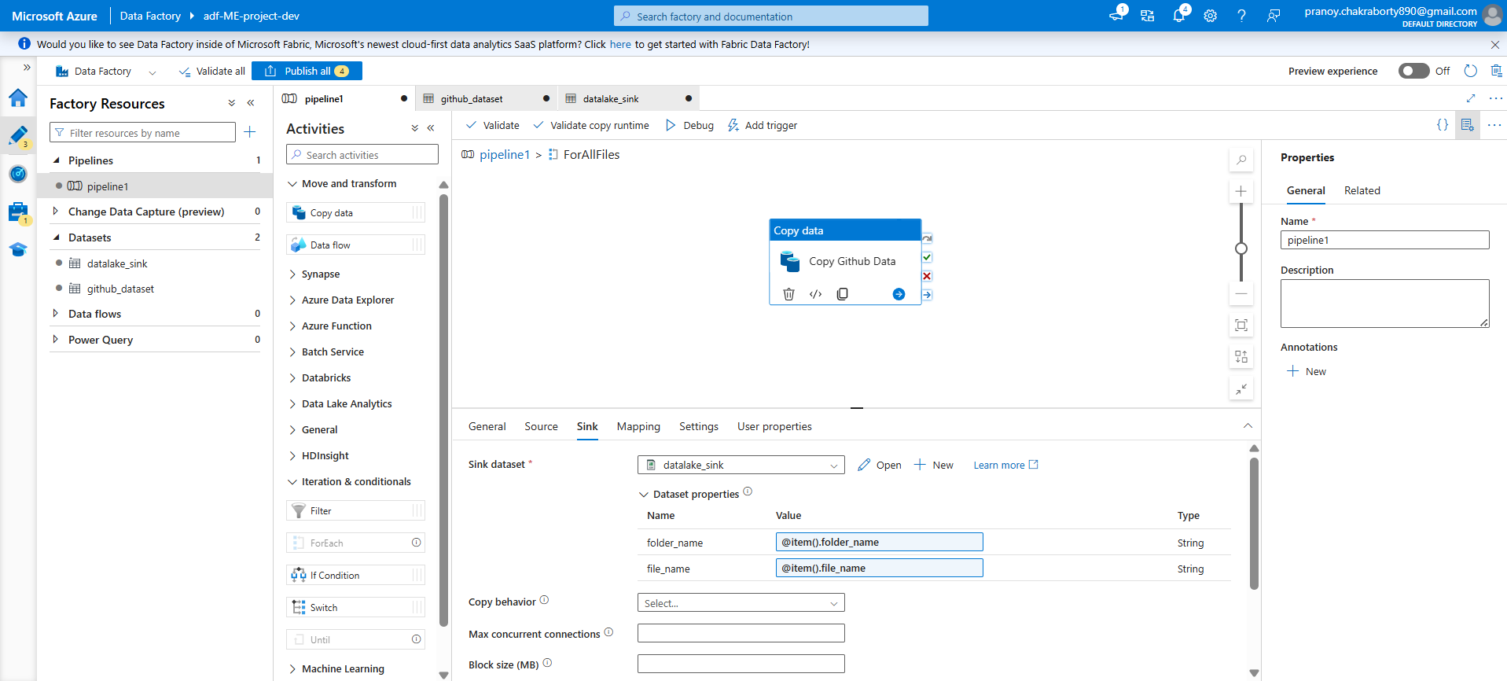

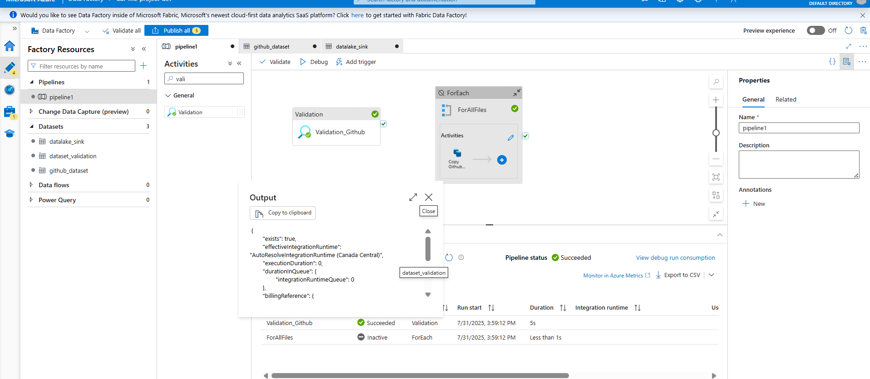

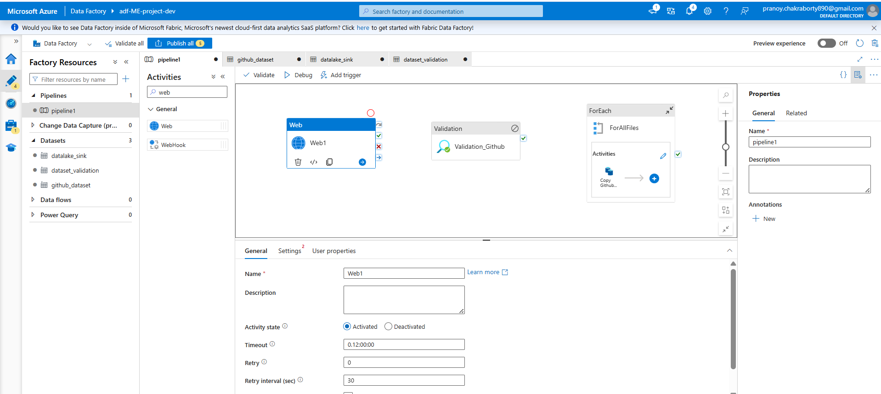

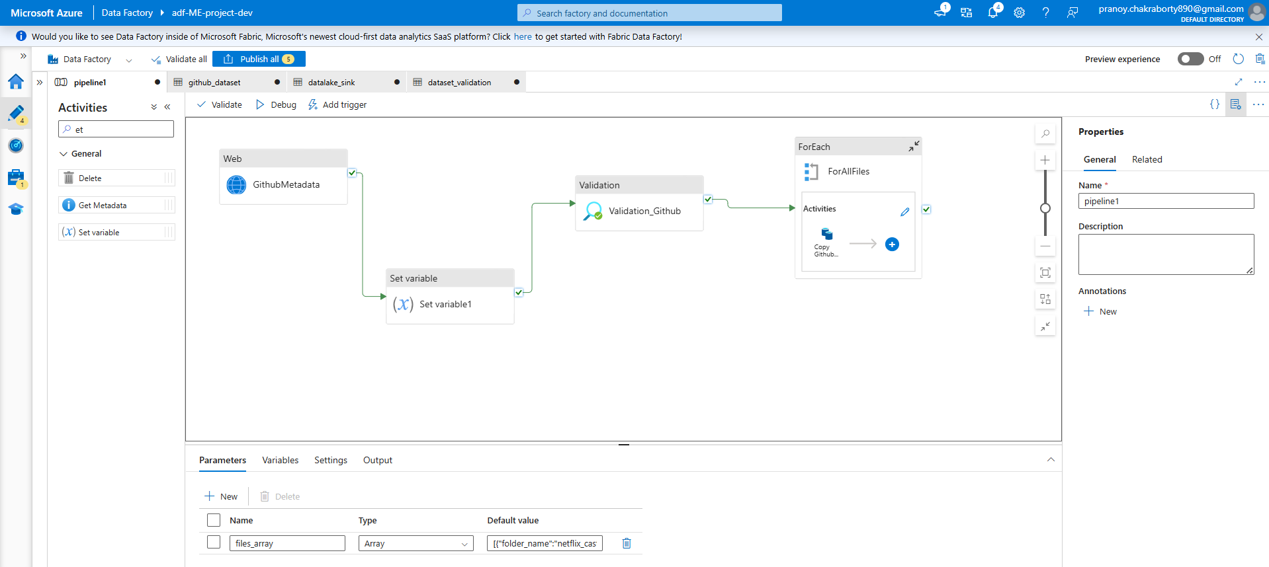

Files Array:

|  |
| --- |
| [  {  "folder_name":"netflix_cast",  "file_name":"netflix_cast.csv"  },  {  "folder_name":"netflix_category",  "file_name":"netflix_category.csv"  },  {  "folder_name":"netflix_countries",  "file_name":"netflix_countries.csv"  },  {  "folder_name":"netflix_directors",  "file_name":"netflix_directors.csv"  }  ] |

Azure Databricks

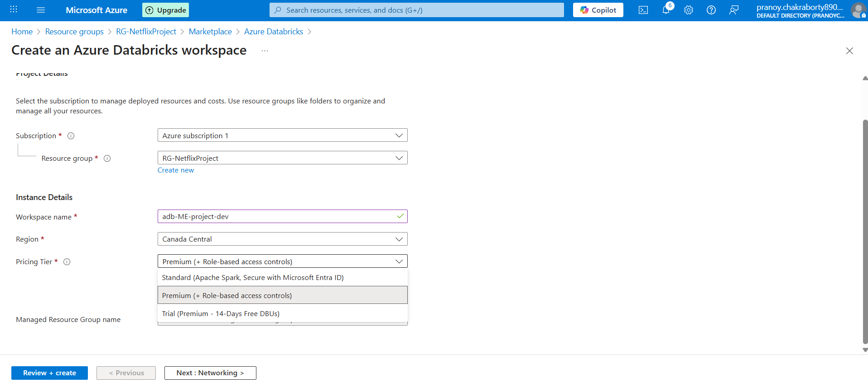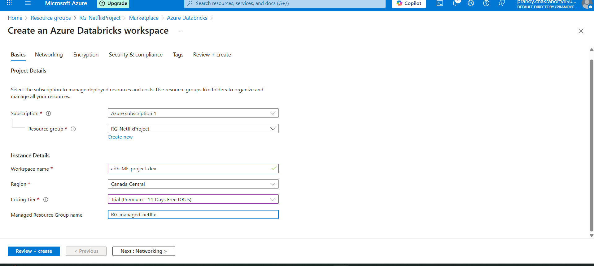

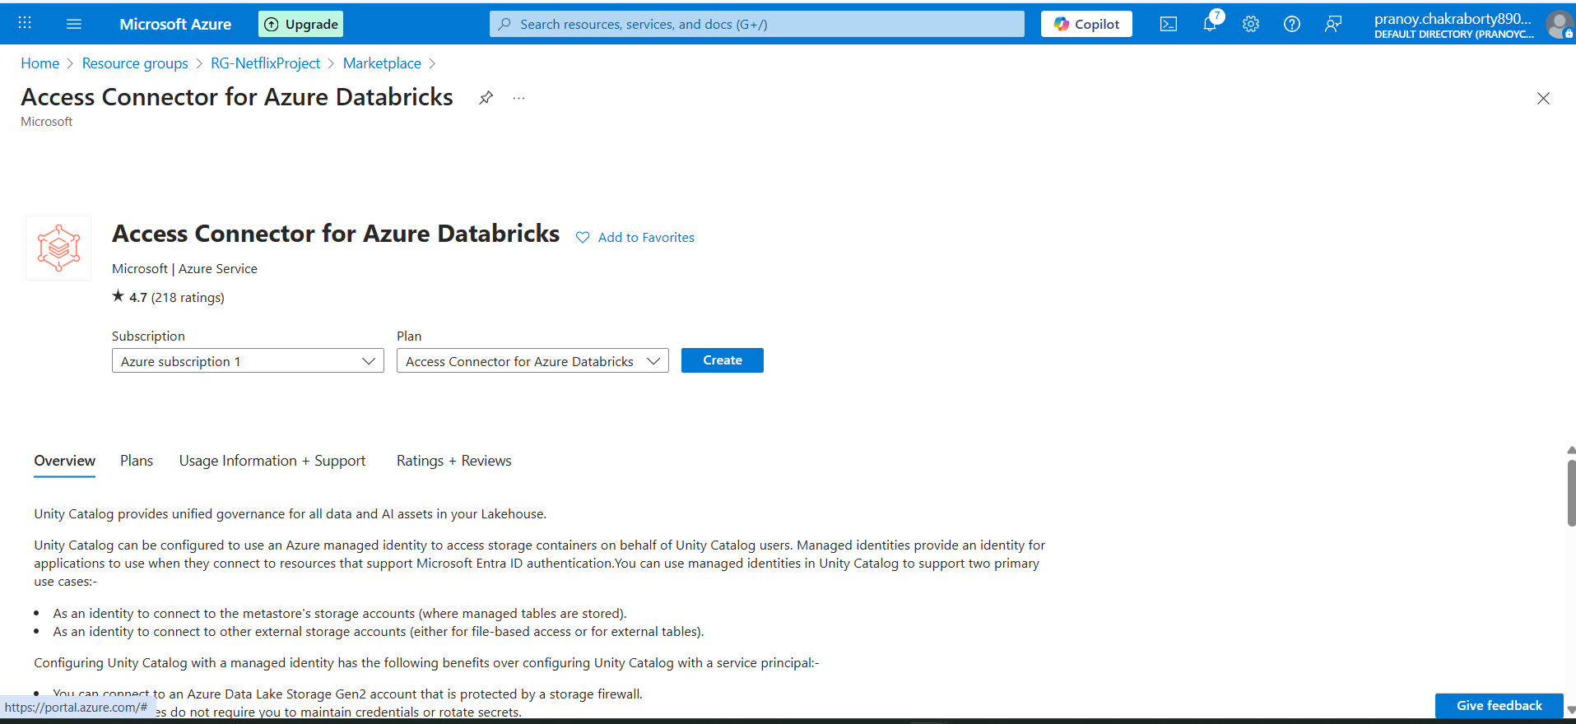

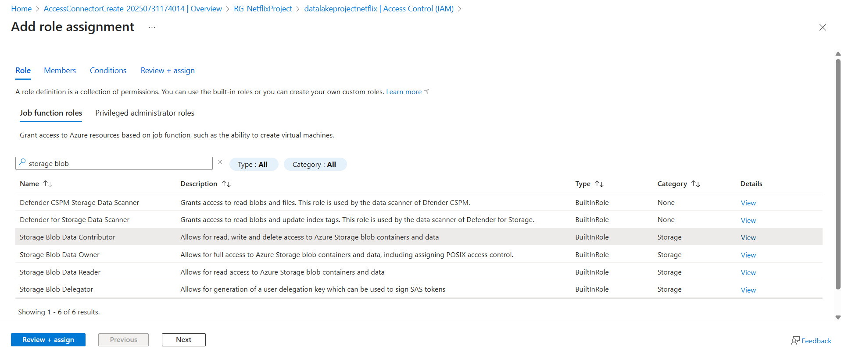

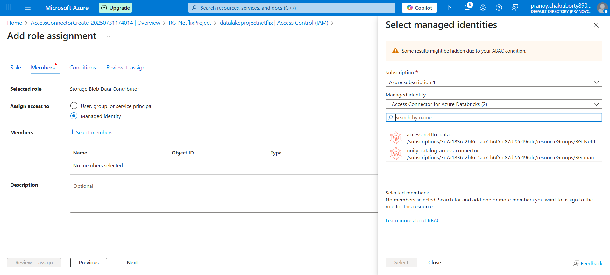

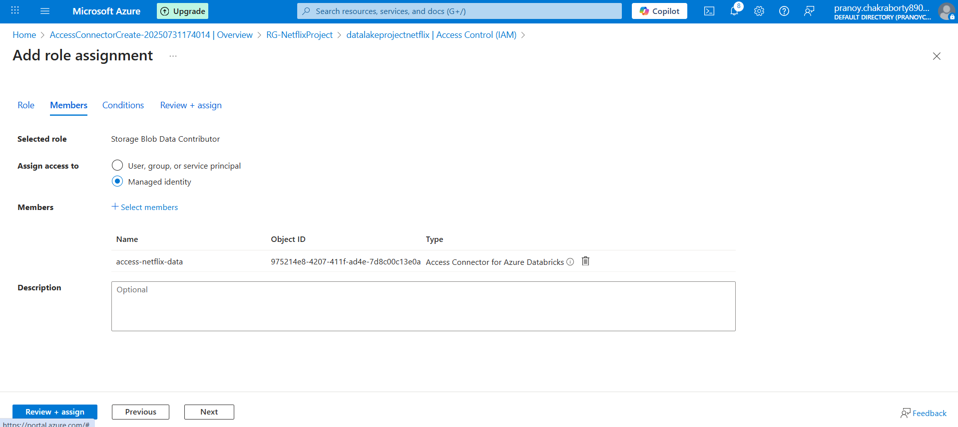

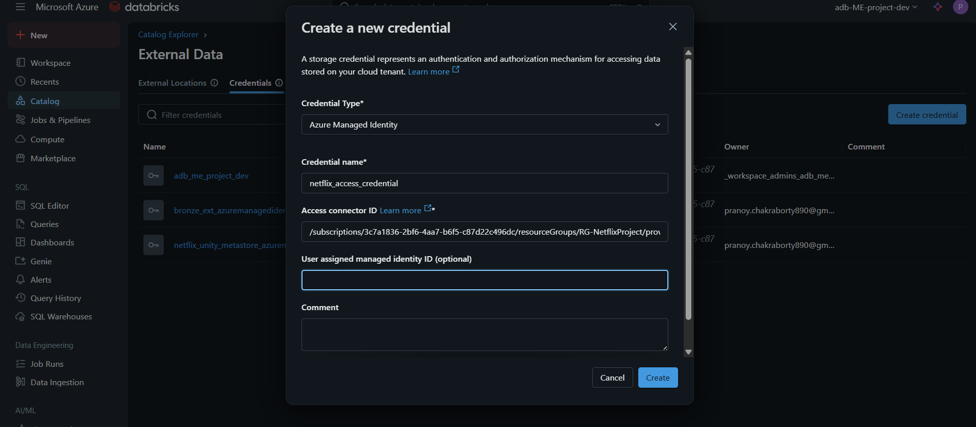

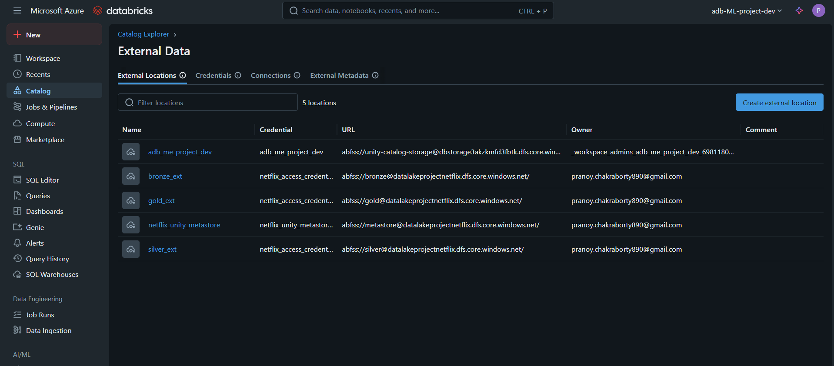

Create Compute:

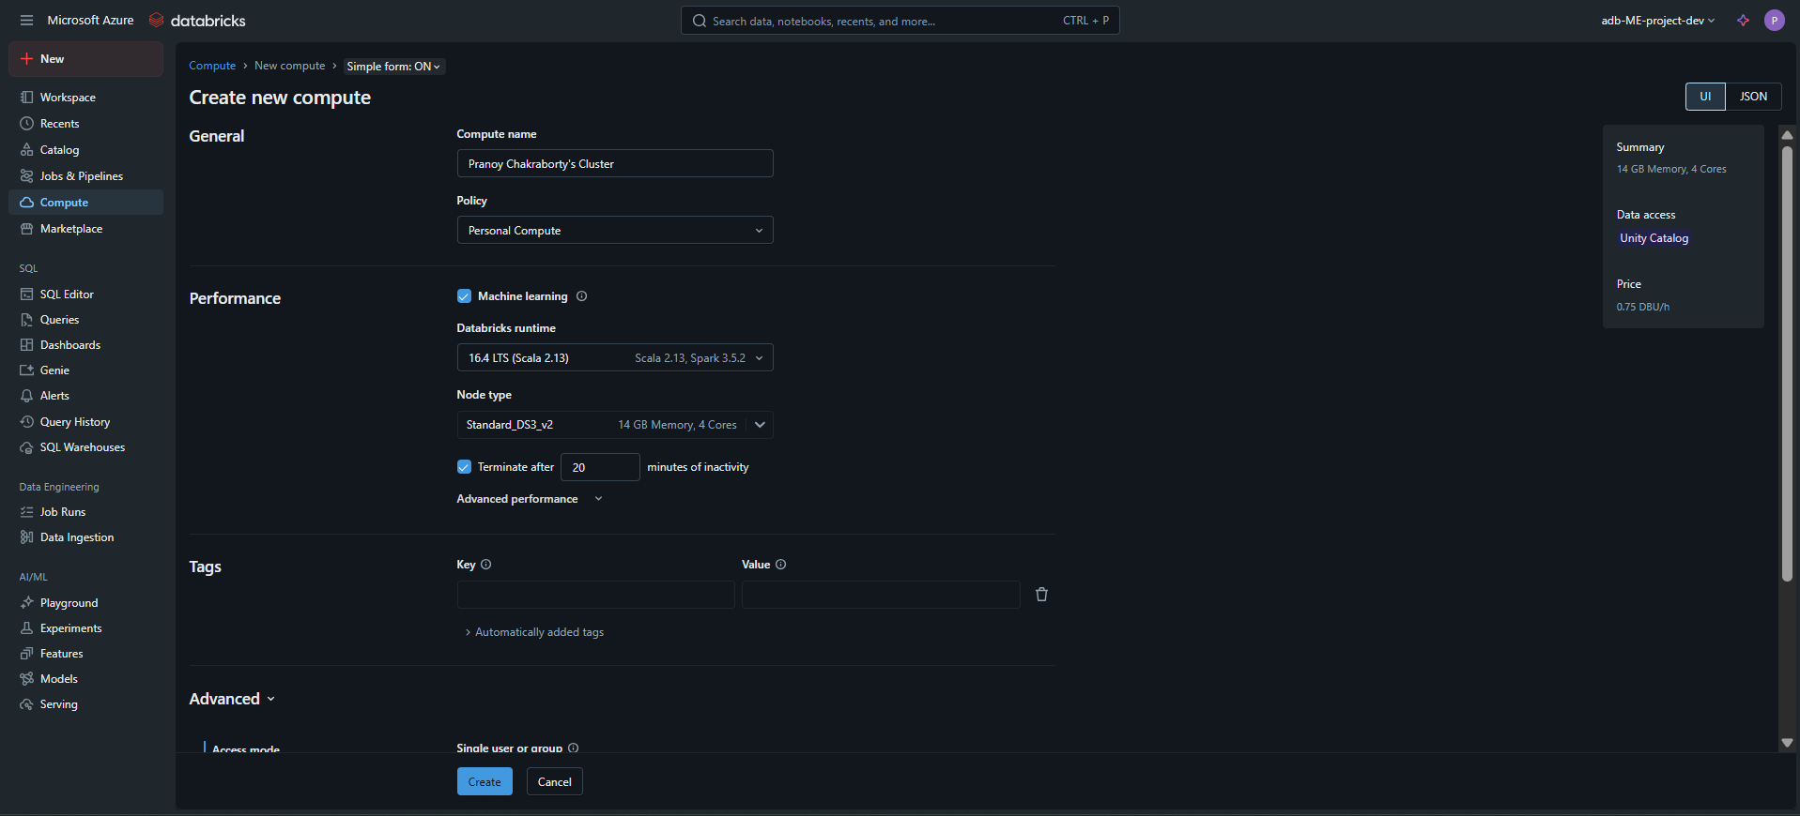

Create Workspace, folder and notebook

Autoloader

Autoloader – Directory Listing, File Notifications

ADLS ----InferSchema (schema location) --- DB ------- ADLS (checkpoint location)

In file